**STEPS TO ACCESSING THE CITI-HUMAN SUBJECTS TRAINING**

Then follow are the following steps:

**1.** Go to [www.citiprogram.org](http://www.citiprogram.org) and click on Register

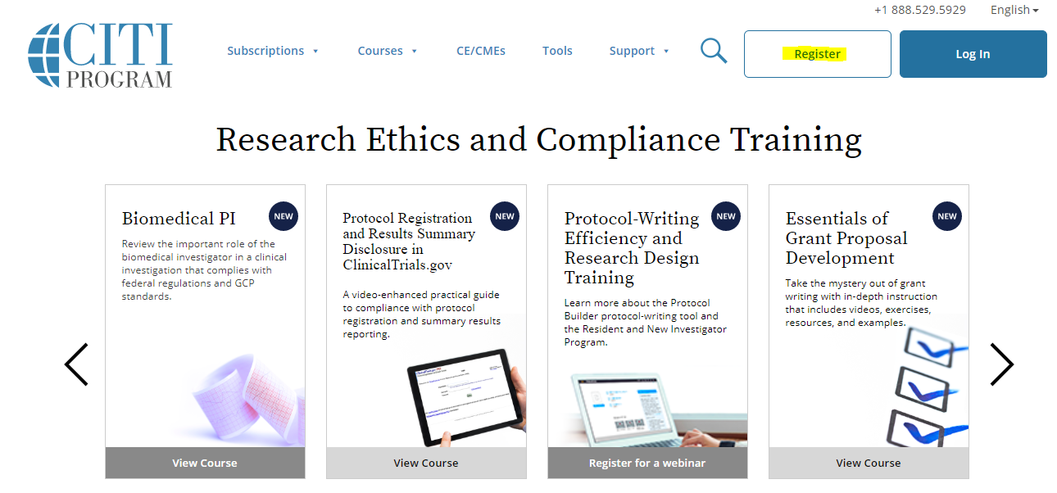

**2.** Select "University of California, San Diego" as your organization (need to type out University of California, San Diego to find)

**3.** Enter your personal information

**4.** Create your user name and password

**5.** Enter country of residence

**6.** Enter yes or no (likely no) for receiving continuing ed courses & yes/no for 2 other required courses

**7.** Enter additional personal info.

For Role in Human Subjects, you can select Research Assistant.

For which course do you plan to take, you can enter one of the first two in the drop down list

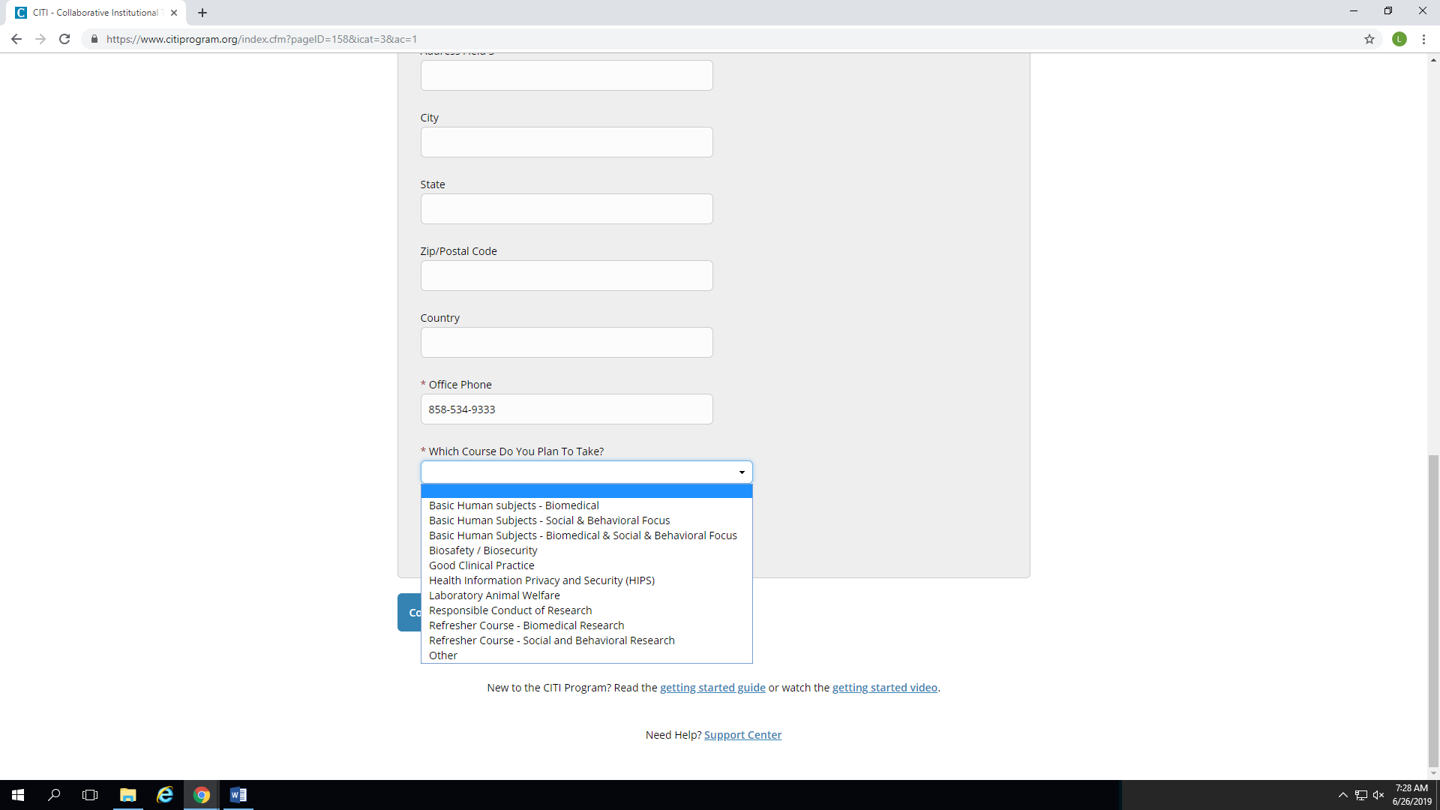

**8.** The next set of questions can be a little tricky:

Question 1 - choose biomedical researchers if you selected the first option from the drop down box on the previous page; choose social & behavioral research if you selected the second option from the drop down box on the previous page

Question 2 - leave blank (you don't need to take any of those courses)

Question 3 - select "I have not completed the basic course"

Question 4 & 5 - select "no en este momento, gracias" for both

Question 6, 7, 9, 10, 12 - select "not at this time"

Question 8 - leave blank

You should be registered after that.  The module has ~16 modules that you need to read and take the corresponding quiz (and pass the quiz).